Stack and Queue
_________________________________________________________________________________

Stack
_____________________________________________________________________________
Stack is data structure which is used for manage the data in last in first out format.
and stack has one pointer name as top which is used for maintain the data position and it help us to
store data in stack and retrieve data from stack as well as delete or update data in stack.

There are two ways to implement the Stack
_____________________________________________________________________________
1. By using Array
2. by using LinkedList

Now we want to stack by using array
_____________________________________________________________________
There are three operations we can perform on stack.

1. PUSH : push operation means we can insert data stack and when we insert data in stack then top of stack increase by 1 and initially top of stack is set by -1 and in the case of push operation there is one situation called as stack overflow or stack full
Stack overflow means we try to store value in stack but there is no space for storing value called as stack overflow.

Following Diagram shows the working of Stack
_____________________________________________________________________________________
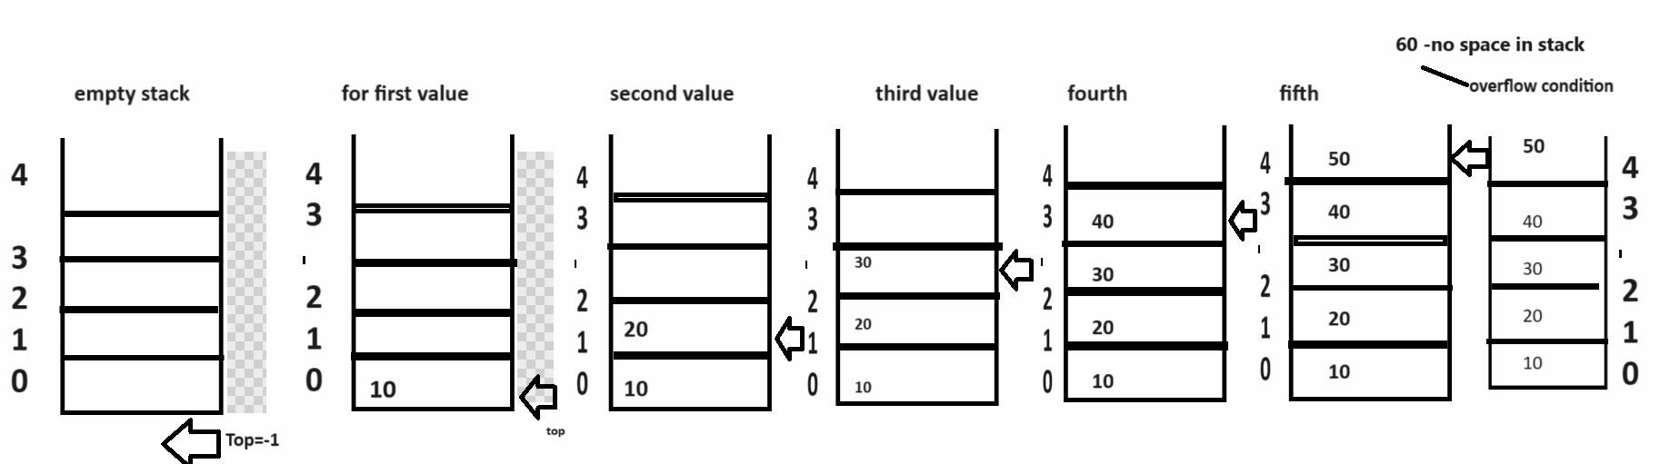

2. POP: POP operation means we delete the value from stack means when we delete the value from stack then top most or last inserted value get deleted first and top decrease by 1 so if we think about POP operation then there is possibility of stack is empty or it is called as underflow.

Following Diagram shows the POP operation
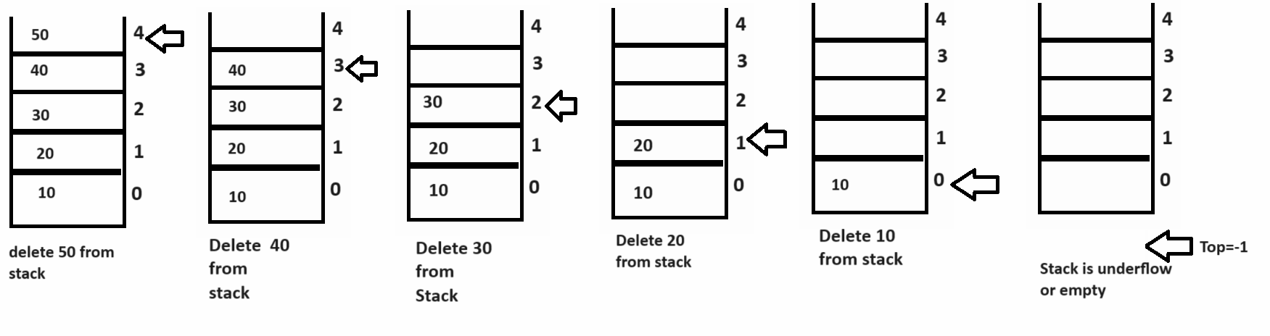

3. DISPLAY : display operation means we travel the stack from top to 0 means we try to display the data of stack in last in first out format.

How to implement the push and pop operation of stack practically
______________________________________________________________________________
If we want to implement the PUSH and POP operation of stack practically we have two algorithm of stack
1. PUSH:
Steps to work with PUSH algorithm

A. DECLARE Array
B. Set TOP as pointer with -1 value
C. Check top ==MAX-1
If top is max -1 then show message stack is full
D. otherwise increase top by 1 and store data in stack
E. repeat step c and d until stack is overflow
F. stop
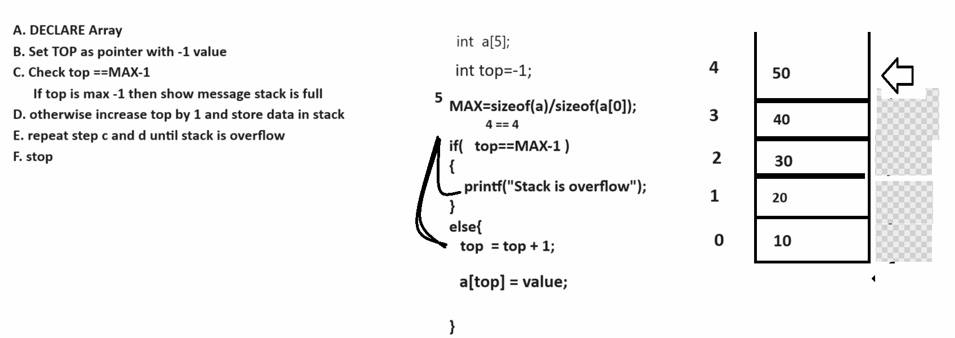
2. POP
Steps to work with POP algorithm

1. DECLARE ARRAY
2. Set top = -1
3. If Top == -1 then stack is underflow
4. Otherwise extract data from stack and display it
5. Decrease top by 1
6. Repeat step 3 and 4 until stack is empty
7. STOP
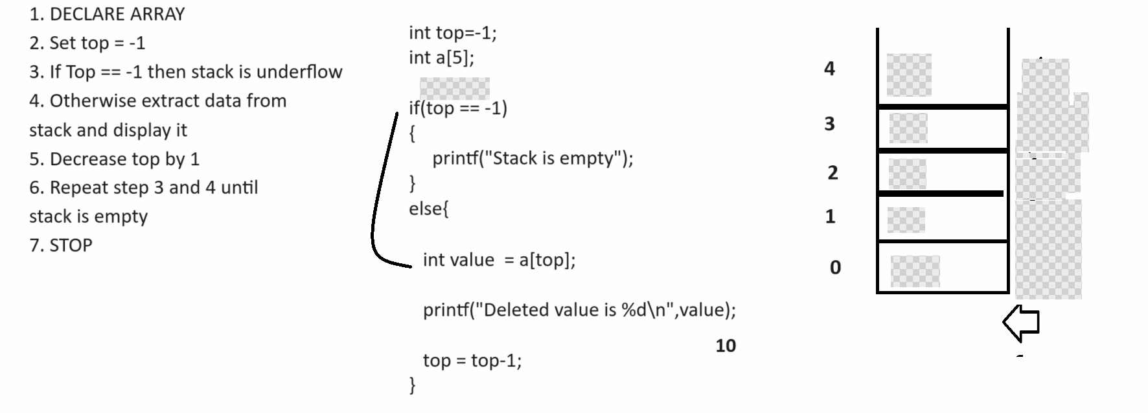
Display logic:
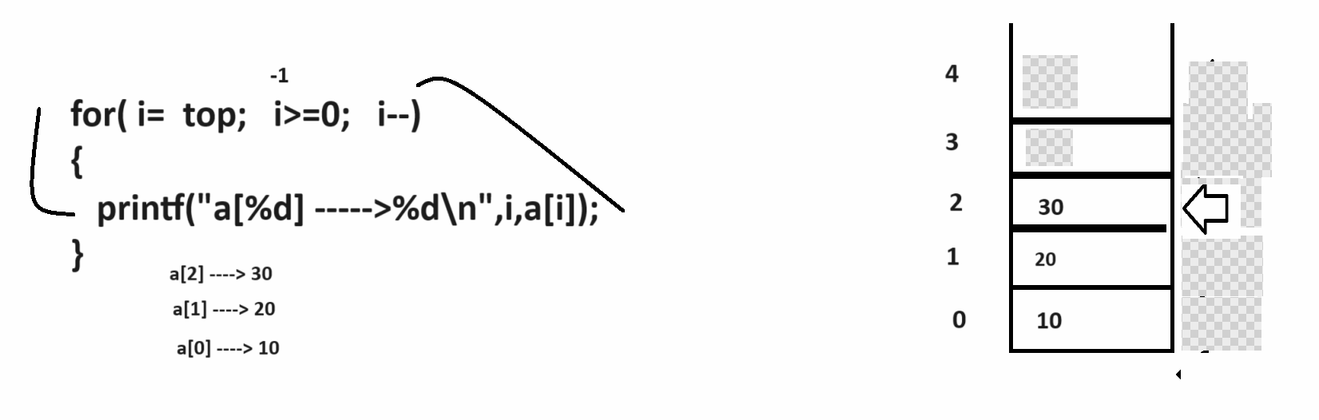

Source code
#include<stdio.h>
#include<conio.h>
void main(){
int a[5],top=-1,i,choice,value,MAX;
MAX=sizeof(a)/sizeof(a[0]);
char ch;
do{
printf("1:PUSH\n");
printf("2:POP\n");
printf("3:DISPLAY\n");
printf("\nEnter your choice\n");
scanf("%d",&choice);
switch(choice)
{
case 1:
printf("\nEnter value in stack\n");
scanf("%d",&value);
if(top==MAX-1)
{ printf("Stack is overflow");
}
else{
top = top+1;
a[top]=value;
}
break;
case 2:
if(top==-1)
{ printf("stack is empty");
}
else{
value=a[top];
printf("deleted value is %d\n",value);
top=top-1;
}
break;
case 3:
if(top==-1)
{ printf("Stack is empty");
}
else{
for(i=top; i>=0;i--)
{ printf("a[%d] --->%d\n",i,a[i]);
}
}
break;
default:
printf("wrong choice\n");
}
printf("\nDo you want to continue\n");
ch=getch();
clrscr(0;
}while(ch=='y' || ch=='Y');

getch();
}

Queue
_______________________________________________________________________________
Queue is used for manage data in first in first out format and queue has two pointers
1. rear and 2. Front so using rear pointer we can insert data in queue and using front pointer we can remove data from queue.
There are two operations can perform on Queue.
1. insert: using insert operation we can store data in queue and if we think about insert operation there is one possibility queue is full.
in the case of insertion operation in initially we have one pointer name as rear and it has default i.e rear=-1 and when we insert element in queue then rear increase by 1 and if rear ==MAX-1 then consider
queue is full
2. delete: using delete operation we can remove data from queue and there is possibility queue is empty.
In the case of delete operation your front is 0 and when we remove the value from queue then front get increase by 1 and when your front==(rear+1) then consider is queue is empty

Following Diagram demonstrate the insertion operation on Queue
__________________________________________________________________________________
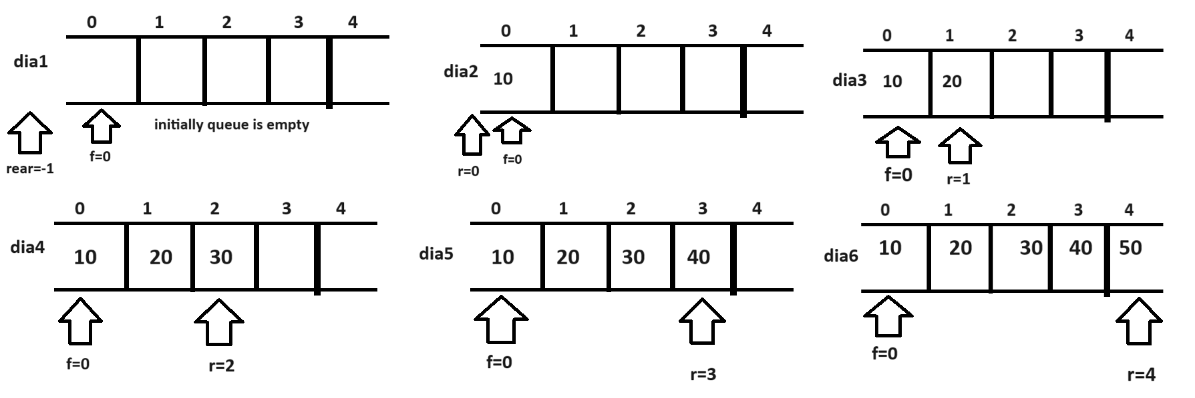
if we think about above diagram and if we try to insert the new value in queue then queue has no space we can say queue is full

Following Diagram demonstrate the deletion operation of Queue
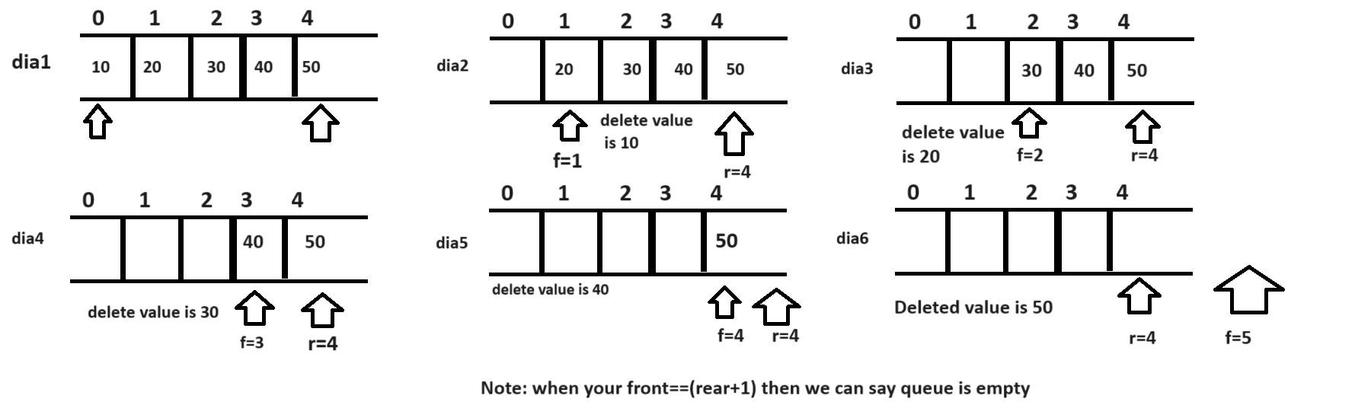

Insert element algorithm of Queue
______________________________________________________________________________
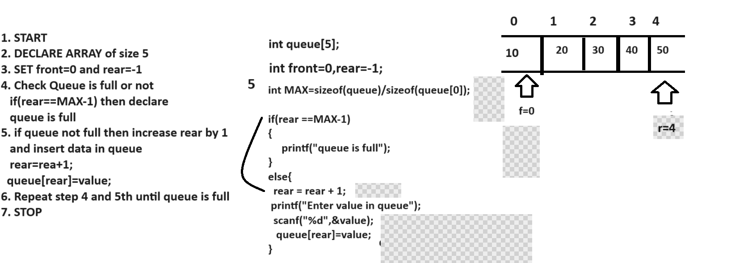

Deletion algorithm of Queue
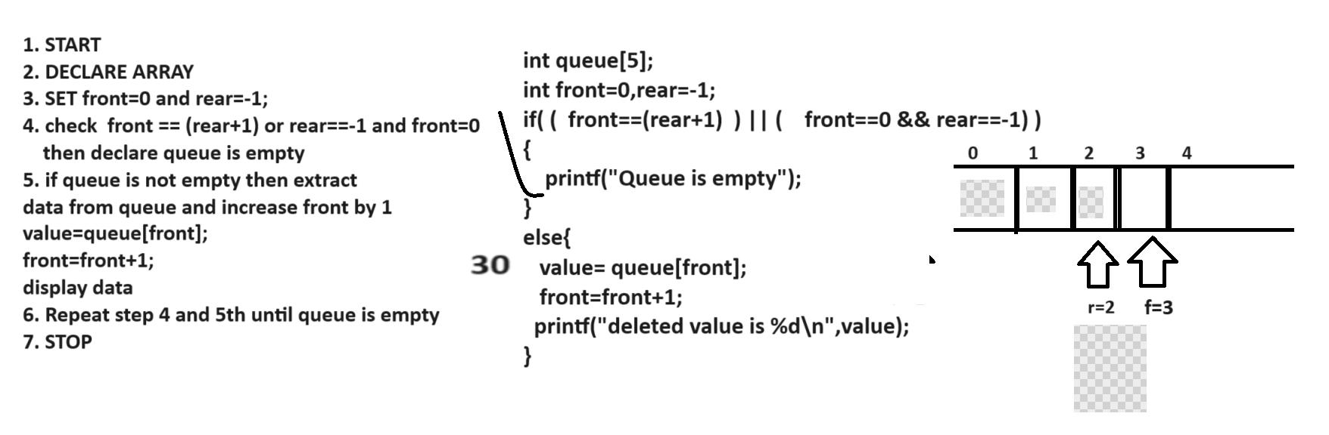

How to fetch data or how to display data of queue
__________________________________________________________________________
if we want to display the data of queue then we can fetch data between front and rear shown in following code and diagram

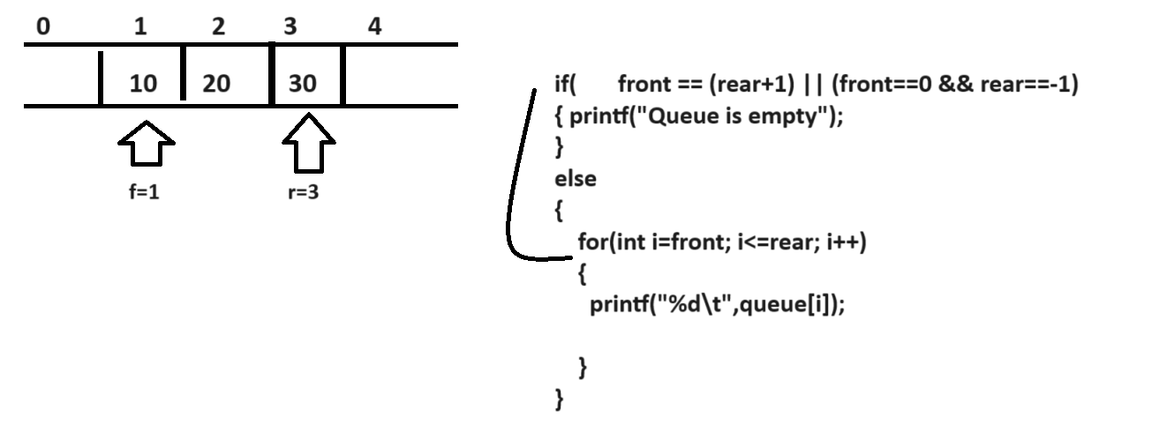

Source code of linear queue
#include<stdio.h>
#include<conio.h>
void main(){
int q[5],front=0,rear=-1,MAX,i,choice,value;
MAX=sizeof(q)/sizeof(q[0]);
char ch;
do{
printf("1:INSERT\n");
printf("2:DELETE\n");
printf("3:DISPLAY\n");
printf("\nEnter your choice\n");
scanf("%d",&choice);
switch(choice)
{
case 1:
if(rear==MAX-1)
{ printf("\nQueue is full\n");
}
else
{
rear=rear+1;
printf("\nEnter value in queue\n");
scanf("%d",&value);
q[rear]=value;
printf("\nData Stored in Queue\n");
}
break;
case 2:
if((front==rear+1) ||(front==0&&rear==-1))
{ printf("\nQueue is empty\n");
}
else{
value=q[front];
front=front+1;
printf("\nDeleted value is %d\n",value);
}
break;
case 3:
if((front==rear+1) ||(front==0 && rear==-1))
{ printf("Queue is empty");
}
else{
for(i=front; i<=rear;i++)
{ printf("%d\t",q[i]);
}
}
break;
default:
printf("\nWrong choice\n");
}
}while(ch=='y' ||ch=='Y');
getch();
}
Note: the major limitation of linear queue is if your rear present at MAX-1 and if front not 0 then we have some space where you can insert data but using linear we cannot insert data in back side of front and if we want to solve this problem we have to use circular queue shown in following diagram
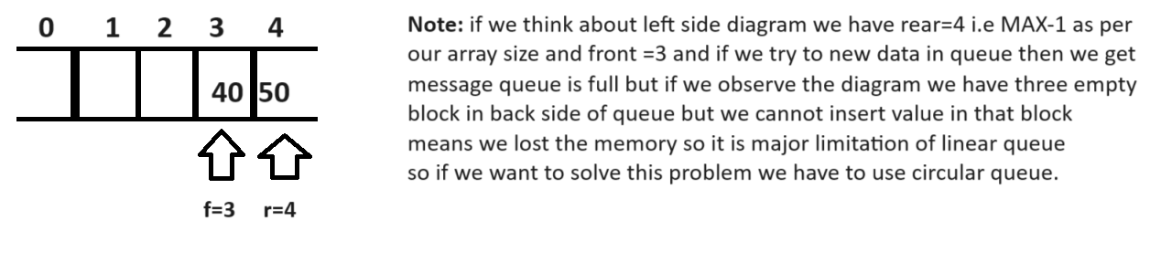

Q. what is circular Queue?
Circular Queue means when your rear points to MAX-1 and front not equal 0 and if we try to insert the
new value in queue then we shift rear behind the front called as circular queue

